

Practical user guide

Authors:
Riccardo Rossi¹ – r.rossi@ing.uniroma2.it
Andrea Murari² - andrea.murari@euro-fusion.org
Luca Martellucci¹ - martellucci@ing.uniroma2.it
Pasquale Gaudio¹ – gaudio@ing.uniroma2.it

¹Department of Industrial Engineering, University of Rome “Tor Vergata”, via del Politecnico 1, Roma, Italy
²Consorzio RFX (CNR, ENEA, INFN, Università di Padova, Acciaierie Venete SpA), Corso Stati Uniti 4, 35127 Padova, Italy

Version 1 – 22/06/2020
Table of contents
Causality Detection 2
Example 1 – Two series causality detection 2
Example 2 – Three series causality detection 3
Time Horizon Detection 5
Example 3 – Time Horizon detection 5
Causality features detection 7
Example 4 – Causality features detection 7

Causality Detection
Given a number of N time series, the causality detection tool computes the “TDNN Causality Detection” described in the SoftwareX paper “A time-delayed neural network tool for causality detection and analysis”. The code returns the F-test results in a NxN matrix, which describes if the i-th time serie influence the j-th time serie.
The causality detection tool is composed of the following four scripts:
- MAIN_TDNN_CausalityDetection.m (main)
- NN_config.m (function)
- NN_train.m (function)
- NN_test.m (function)
Each script contains comments which explain the steps.
The folder contains also the script “MAIN_generate_system.m”. It can be used to generate three Lorentz systems, which interacts between them, to test the algorithm. The user can change the parameter “miji”. If zero, it means the j-th system does not influence the i-th system. Values different from zero involve an influence.

Example 1 – Two time series causality detection
Run the script “MAIN_generate_system.m” with the following parameters:
Nt = 1e4+1;
dt = 0.005;

sigma = 10;
r = 28;
b = 8/3;

mi21 = 0;
mi31 = 0;
mi12 = 0.5;
mi32 = 0;
mi13 = 0;
mi23 = 0;

I_noise = 0.02;

The script generates the time series X which influences Y, but not vice versa.
Open the script “MAIN_TDNN_CausalityDetection.m”. In the first lines of the code, you have to set the inputs in a cell array named S, where each cell contains the system. In this case, the first cell contains X (x1,x2 and x3), while the second cell contains Y (y1,y2 and y3). Please, remove the third cell at this stage (just using a % before the line):
S{1}=X;
S{2}=Y;
% S{3}=Z;

Parallel computing can be used. In this case, set parallel_computing equal to 1. Otherwise, it should be zero.
parallel_computing = 1;

Choice the p-value threshold. In the code, it is set equal to 0.05.
p_three = 0.05;

Run the code. Depending on the user’s computer hardware and parallel computing set, the software may require a while. At the end of the computing, a figure is plotted (Figure 1).

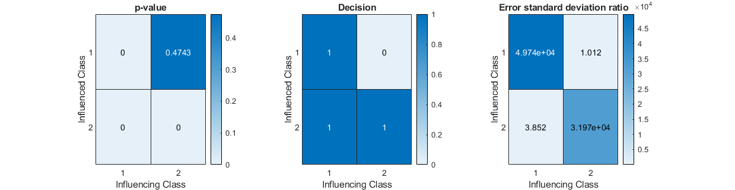
Figure 1: Example 1 results.
The table on the left shows the p-values of the F-tests. For example, the p-value of the F-test in the case of row 2 and column 1 is 0, and you can conclude (taking into account your “p-value related error”) that the class 1 influence the class 2, thus that X influences the time series Y (as it has been imposed by the mi12), while Y does not influences X (p-value equal to 0.4743).
The second table shows the decision taken by the test. It is based on comparing the p-value with the p-value threshold. In this case, there are three 1 which indicates that X influences X and Y, Y influences Y but not X.
The last table shows the variance ratios, id est the ratio between the variance of the error when the model uses i to predict j with respect to when it uses both. This parameter is proportional to strength of the influence. In this case, X is strongly influenced by X and less influenced by Y. When it is equal to 1, it means that there is not influence and the p-value should be large. If this ratio is much smaller than one (if it is smaller and the p-value is smaller than your threshold), the result is controversial and you should run again (basically, the neural network did not converge to the best result). However, a Boolean condition has been integrated and the decision turns to zero if the p-value is small and the variance ratio is smaller than one.
Please note that each time series is influenced by itself, due to the definition of the Lorentz system.

Example 2 – Three time series causality detection
Run the script “MAIN_generate_system.m” with the following parameters:
Nt = 1e4+1;
dt = 0.005;

sigma = 10;
r = 28;
b = 8/3;

mi21 = 0;
mi31 = 0;
mi12 = 0.5;
mi32 = 0;
mi13 = 0;
mi23 = 2;

I_noise = 0.02;

The script generates the time series X which influences Y and in its turn the time series Y influences Z.
Open the script “MAIN_TDNN_CausalityDetection.m” and set the in the cell array to analyse “S” the X, Y and Z time series:
S{1} = X;
S{2} = Y;
S{3} = Z;

Parallel computing can be used. In this case, set parallel_computing equal to 1. Otherwise, it should be zero.
parallel_computing = 1;

Choice the p-value threshold. In the code, it is set equal to 0.05.
p_three = 0.05;

Run the code and wait for the results. You should obtain figures similar to Figure 2.
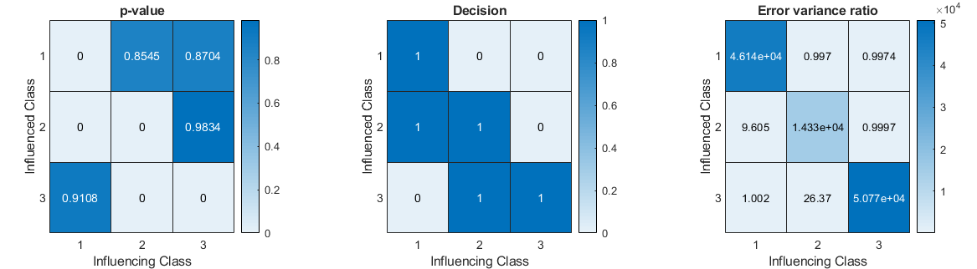
Figure 2: Example 2 results.

The p-value and the decision are in accordance with the expected results and imposed influences (using the miji).
Class 1 (X) influences class 2 (Y) and class 2 (Y) influences class 3 (Z). Moreover, each class influences itself.

Time Horizon Detection
Given a time series X which influences a time series Y, it could be interesting to measure the time horizons of the influence, id est the time difference between the influencing event of X and the influenced event in Y.
The algorithm is compounded by four functions:
- MAIN_TDNN_HorizonTimeDetection.m (main)
- NN_config.m (function)
- NN_train.m (function)
- NN_test.m (function)
Each script contains comments which explain the steps.
The folder contains also the script “MAIN_generate_system_forTimeHorizon.m”. It can be used to generate one Lorentz system which is influenced by an y vector, randomly generated. The user can change the parameter “mi”. If zero, it means the y does not influence the Lorentz system. Values different from zero involve an influence. See following examples.
The parameter dt_inf defines the time delay. The minimum value is 1 and it has to be an integer.

Example 3 – Time Horizon detection
Run the script “MAIN_generate_system_forTimeHorizon.m” with the following parameters:
Nt = 1e4+1;
dt = 0.005;
t = 0:dt:(Nt-1)*dt;

sigma = 10;
r = 28;
b = 8/3;

mi = 10;

dt_inf = 3;

I_noise = 0.02;

This routine generates the system X, which depends on the time series y. The variable y is randomly generated. The parameter dt_inf defines the time delay.
Then, run the routine MAIN_TDNN_HorizonTimeDetection with the following parameters:
Sin = y;

Sout = X;

T{1} = 1:1;
T{2} = 1:2;
T{3} = 1:3;
T{4} = 1:4;
T{5} = 1:5;

The routine returns the graph of Figure 3. The left plot shows the variance ratio between the model using the y series as input and not, while the plot on the right shows the result of the F-test. For the first two time delays, the error variance ratio is equal to one and the F-test is 0. It means that using y at these time delays does not produce an improvement in the accuracy of the model and so that y does not affect the prediction of X. Increasing the time delay to three, the variance ratio increases to 9 and the F-test is 1. Thus, y becomes useful to predict X and it means that y has a delay of three counts, as imposed from the dt_inf parameter. Increasing the time delay, the y is still important (because the code uses all previous time delays, 3 included) but the error variance ratio remains almost equal to the case of a delay of three. Thus, it is possible to conclude that the y influences the X with a time delay equal 3.
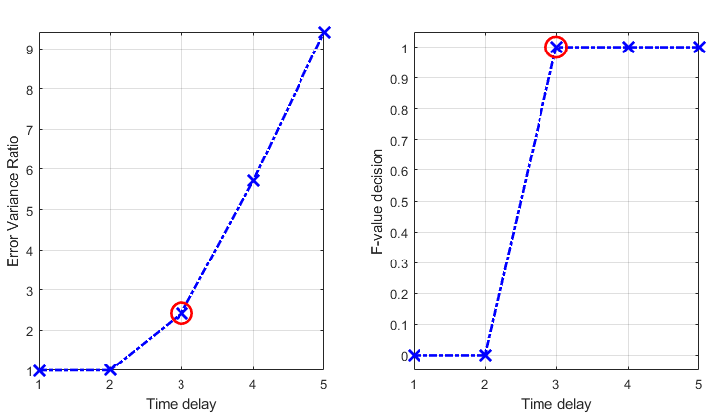
Figure 3: Example 3 results.

Causality features detection
Sometimes, it can happen that a system influences another system only in specific cases. This could be due to thresholds, Booleans conditions, etc. It may be interesting to be able to detect at which time instances the influences occur, in order to extract additional information about causality.
The causality feature detection tool allows to extract these features. The algorithm is compounded by for routines:
- MAIN_TDNN_FeatureCausalityDetection.m (main)
- NN_config.m (function)
- NN_train.m (function)
- NN_test.m (function)
Each script contains specific comments which explain the algorithm step by step.
Moreover, another script is provided to generate data to perform tests. The script is called “MAIN_generate_system_forFeatureDetection”. It is equal to the MAIN_generate_system.m, the only difference is that the coefficient mi12 is not constant but changes with a boolean condition. If x2 is higher than a threshold (default value is 10), the interaction coefficient is the one set on the top of the code (mi12), otherwise it is zero.

Example 4 – Causality features detection
Run the MAIN_generate_system_forFeatureDetection to generate the data. Standard parameters will generate three Lorentz systems: X, Y and Z. Y depends on Z with a constants interaction coefficient (mi23 = 1), while the X series influences the Y series only when x2 is higher than 10. The algorithm displays two different figures. The first one shows the three Lorentz systems, while the second figure shows the effective interaction coefficient between X and Y (mi12) as a function of time. You should obtain a figure like this:
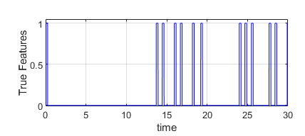
Figure 4: Mi12 vs time.
Now, you can run the MAIN_TDNN_FeatureCausalityDetection with the following setup:
Sin = X;

Sin_other = [];

Sout=Y;

The script will print a figure like that:
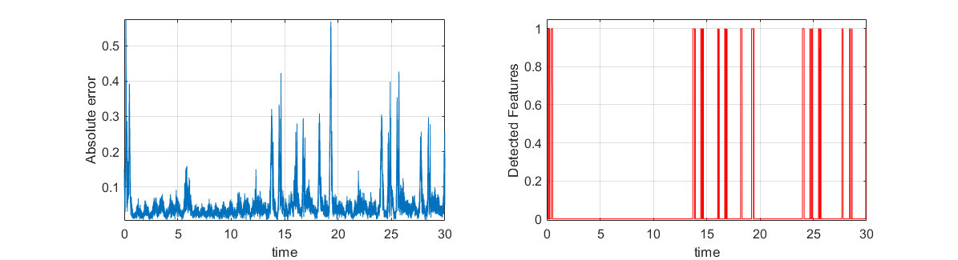
Figure 5: Results of Example 4 - part 1.
On the left of the figure, the absolute error variable (see paper) is shown. You can see that there are peaks where the error is large, while the right figure shows the detected intervals of effective interactions, which correspond exactly to the imposed ones (see Figure 4).
The second part consists in checking the features of Y on Z, which should be flat and equal to zero at any time.
Run the script MAIN_TDNN_FeatureCausalityDetection with the following parameters:
Sin = Y;

Sin_other = [];

Sout = Z;

The output of the code will be a figure like the following:
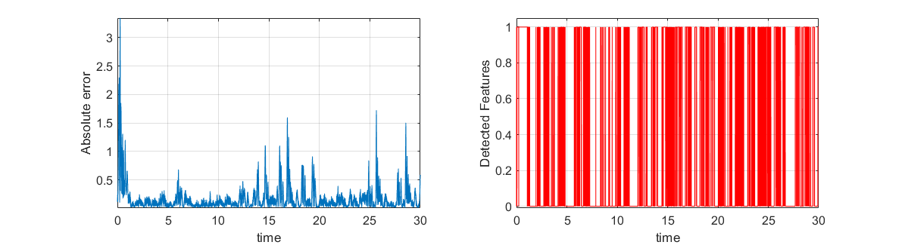
Figure 6: Results of Example 4 - part 2.
In this case, the code detects many features but not a continuous one. This is an apparent error. This issue is due to the fact that Y does not influence Z not only when mi23 is zero (never in this case), but also when y2 is equal to zero or it is very small.
Performing a post processing analysis, the values of y₂ when the detected features are equal to 1 and 0 can be investigated. This analysis shows that the mean of the absolute value of y₂ when the detected features is equal to 0 is 2, while in the case of features equal to 1, the mean is 12.

